

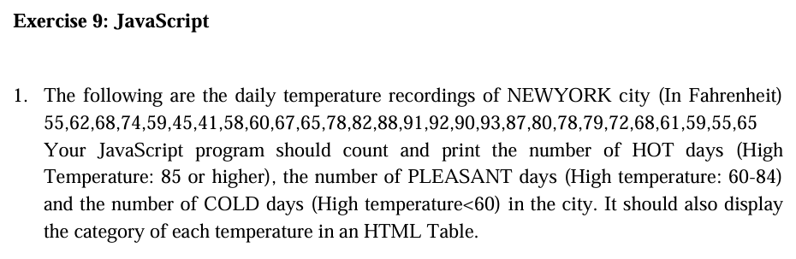

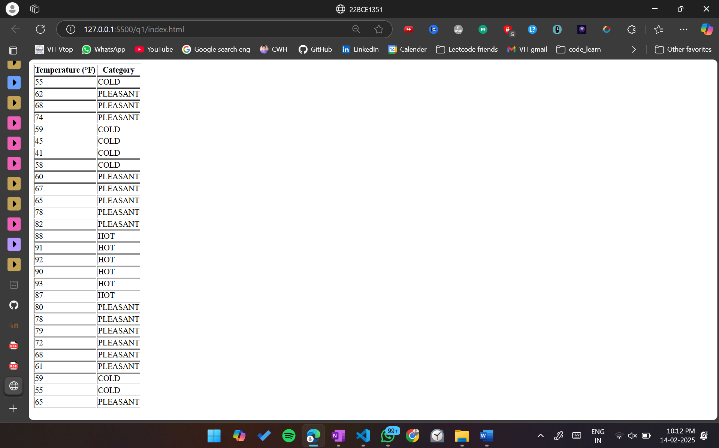

<!DOCTYPE html>

<html lang="en">

  <head>

    <meta charset="UTF-8" />

    <meta name="viewport" content="width=device-width, initial-scale=1.0" />

    <title>22BCE1351</title>

  </head>

  <body>

    <table border="1">

      <tr>

        <th>Temperature (°F)</th>

        <th>Category</th>

      </tr>

    </table>

    <script>

      const temperatures = [

        55, 62, 68, 74, 59, 45, 41, 58, 60, 67, 65, 78, 82, 88, 91, 92, 90, 93,

        87, 80, 78, 79, 72, 68, 61, 59, 55, 65,

      ];

      let hotDays = 0;

      let pleasantDays = 0;

      let coldDays = 0;

      const table = document.querySelector("table");

      temperatures.forEach((temp) => {

        let category;

        if (temp >= 85) {

          hotDays++;

          category = "HOT";

        } else if (temp >= 60) {

          pleasantDays++;

          category = "PLEASANT";

        } else {

          coldDays++;

          category = "COLD";

        }

        const row = document.createElement("tr");

        row.innerHTML = `<td>${temp}</td><td>${category}</td>`;

        table.appendChild(row);

      });

      console.log(`HOT days: ${hotDays}`);

      console.log(`PLEASANT days: ${pleasantDays}`);

      console.log(`COLD days: ${coldDays}`);

    </script>

  </body>

</html>

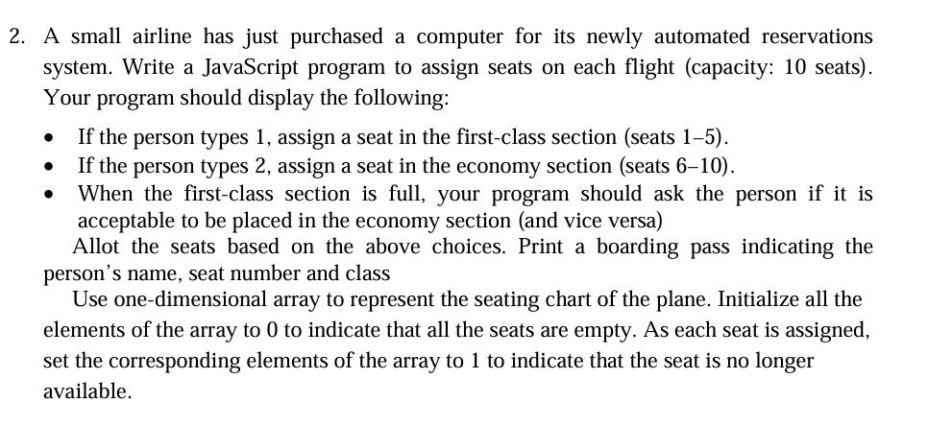

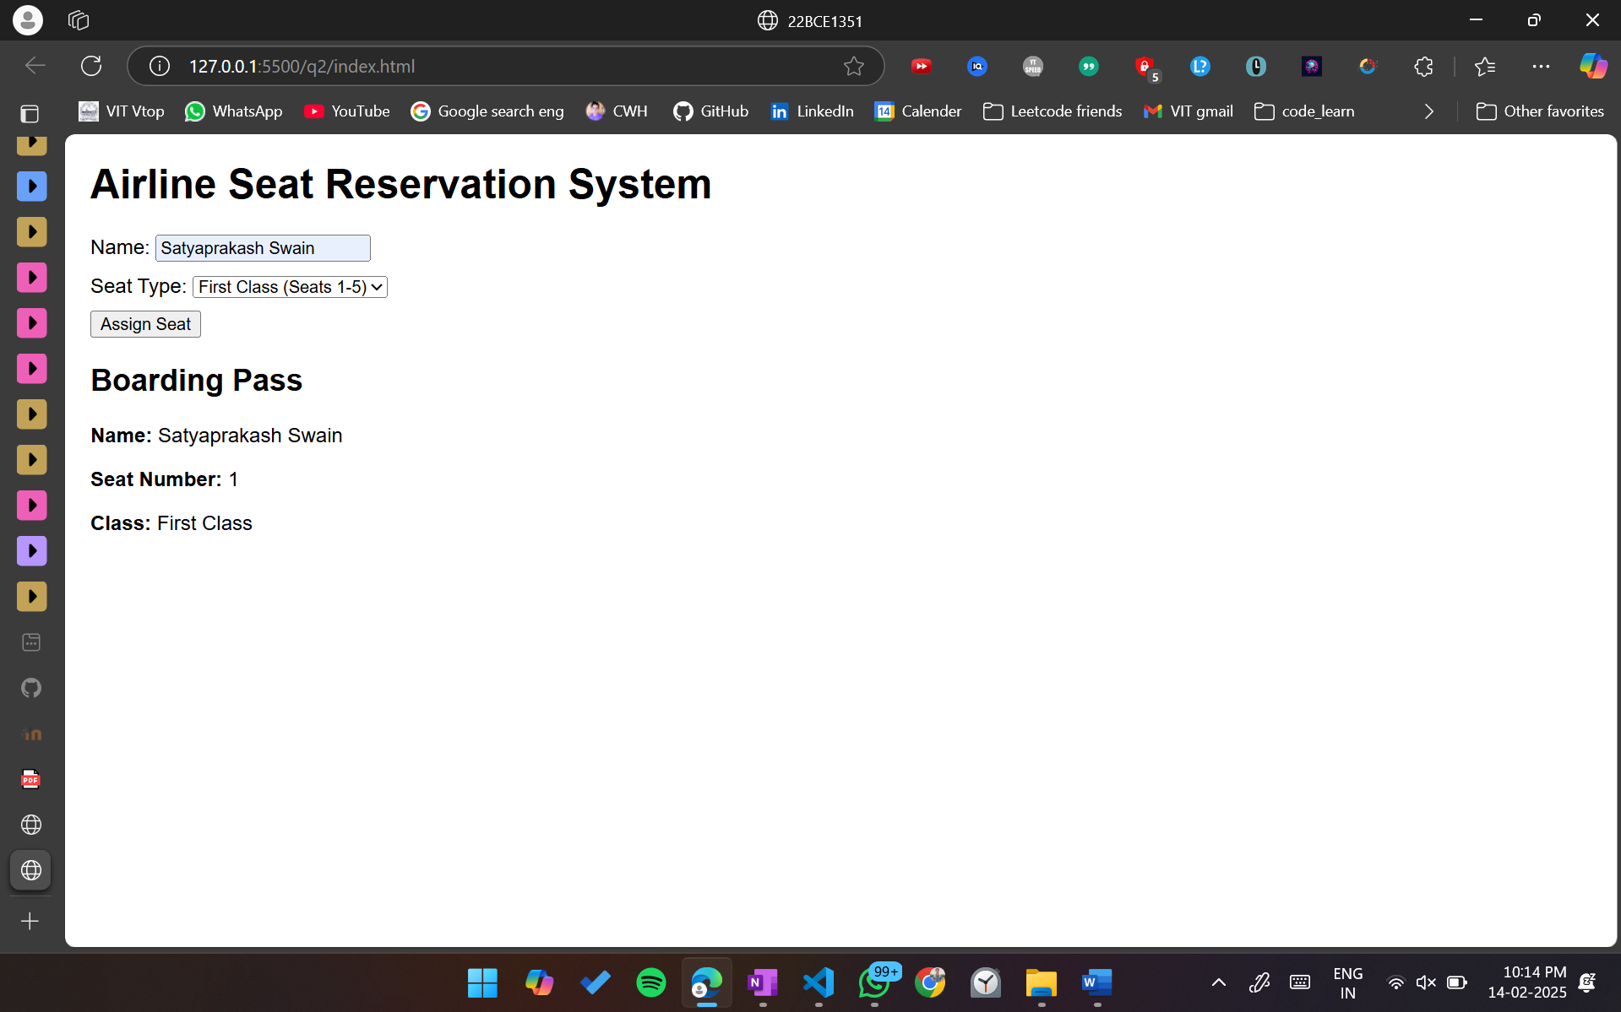

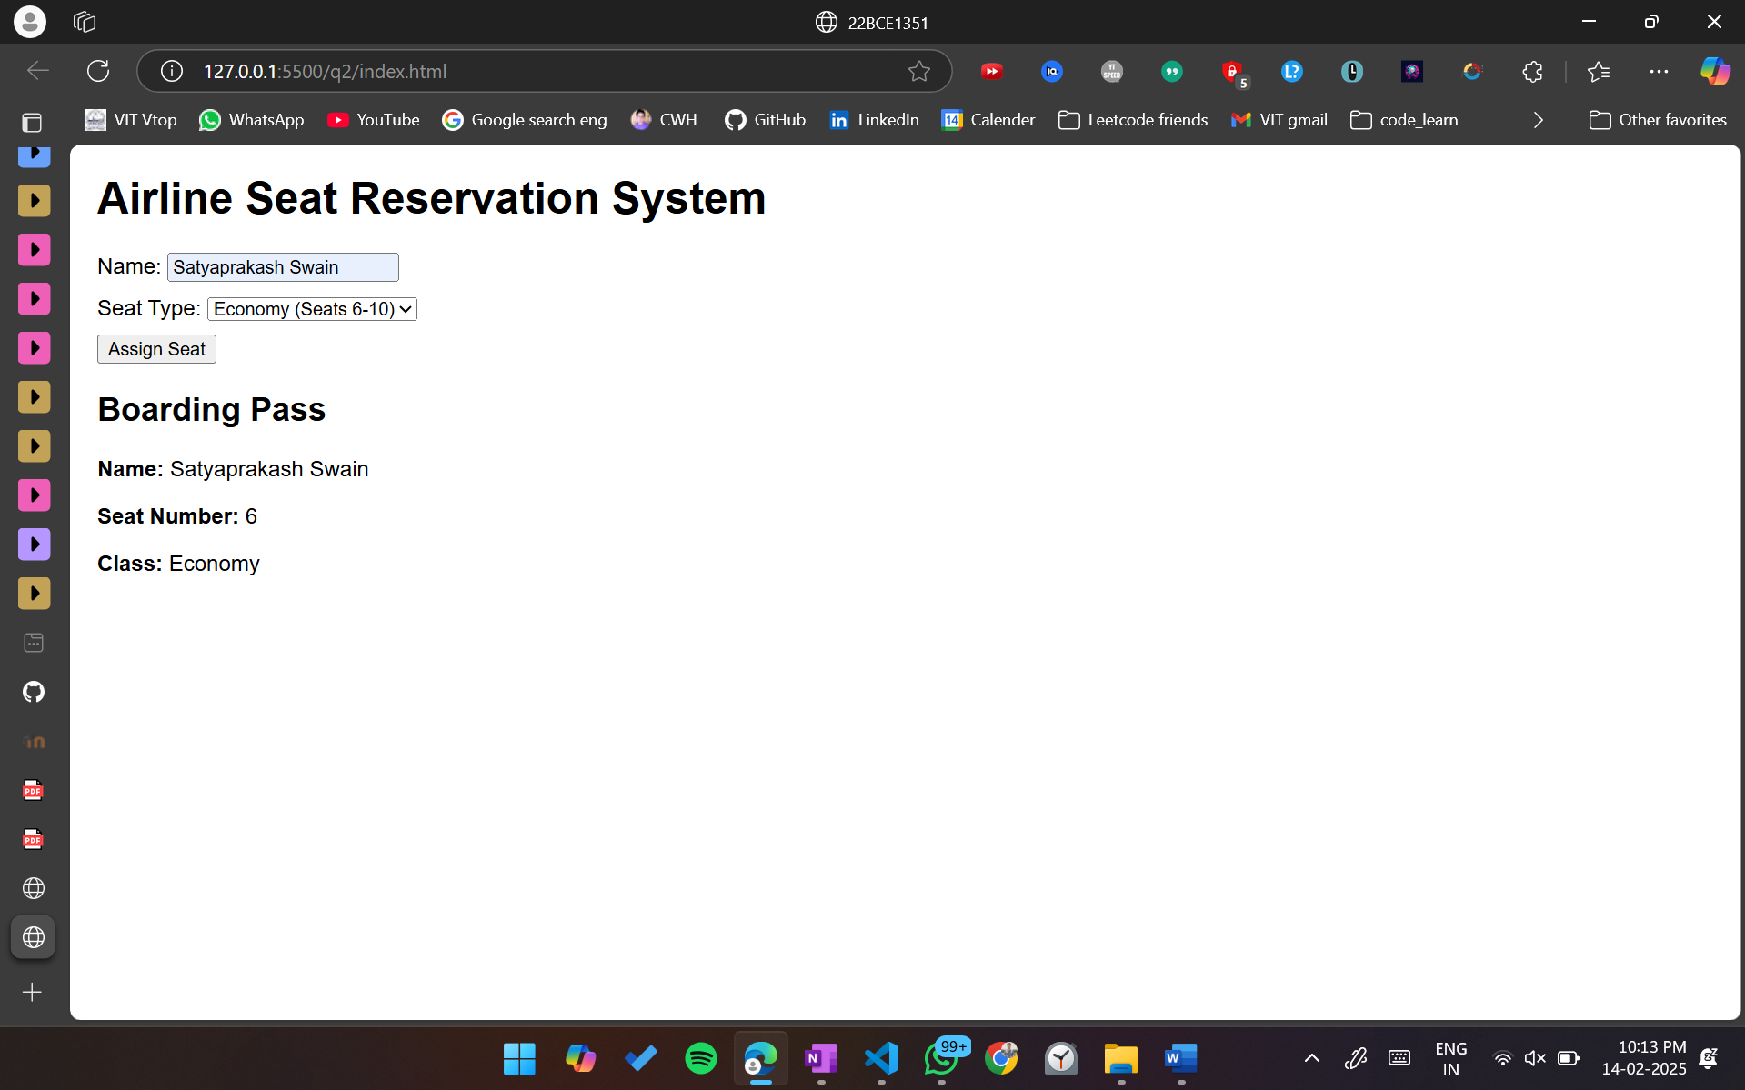

<!DOCTYPE html>

<html lang="en">

<head>

  <meta charset="UTF-8" />

  <meta name="viewport" content="width=device-width, initial-scale=1.0" />

  <title>22BCE1351</title>

  <style>

    body {

      font-family: Arial, sans-serif;

      margin: 20px;

    }

    .seat {

      margin-bottom: 10px;

    }

  </style>

</head>

<body>

  <h1>Airline Seat Reservation System</h1>

  <div class="seat">

    <label for="name">Name:</label>

    <input type="text" id="name" placeholder="Enter your name" />

  </div>

  <div class="seat">

    <label for="seatType">Seat Type:</label>

    <select id="seatType">

      <option value="1">First Class (Seats 1-5)</option>

      <option value="2">Economy (Seats 6-10)</option>

    </select>

  </div>

  <button onclick="assignSeat()">Assign Seat</button>

  <div id="boardingPass" style="margin-top: 20px"></div>

  <script>

    let seatingChart = [0, 0, 0, 0, 0, 0, 0, 0, 0, 0];

    function assignSeat() {

      const name = document.getElementById("name").value;

      const seatType = document.getElementById("seatType").value;

      let seatNumber = -1;

      if (seatType === "1") {

        seatNumber = assignSeatInSection(1, 5);

      } else if (seatType === "2") {

        seatNumber = assignSeatInSection(6, 10);

      }

      if (seatNumber === -1) {

        const isAcceptable = confirm(

          "Your preferred section is full. Is it acceptable to be placed in the other section?"

        );

        if (isAcceptable) {

          if (seatType === "1") {

            seatNumber = assignSeatInSection(6, 10);

          } else {

            seatNumber = assignSeatInSection(1, 5);

          }

        }

      }

      if (seatNumber !== -1) {

        seatingChart[seatNumber - 1] = 1;

        displayBoardingPass(

          name,

          seatNumber,

          seatNumber <= 5 ? "First Class" : "Economy"

        );

      } else {

        alert("Sorry, the flight is full.");

      }

    }

    function assignSeatInSection(start, end) {

      for (let i = start - 1; i < end; i++) {

        if (seatingChart[i] === 0) {

          return i + 1;

        }

      }

      return -1;

    }

    function displayBoardingPass(name, seatNumber, seatClass) {

      const boardingPassDiv = document.getElementById("boardingPass");

      boardingPassDiv.innerHTML = `

                <h2>Boarding Pass</h2>

                <p><strong>Name:</strong> ${name}</p>

                <p><strong>Seat Number:</strong> ${seatNumber}</p>

                <p><strong>Class:</strong> ${seatClass}</p>

            `;

    }

  </script>

</body>

</html>



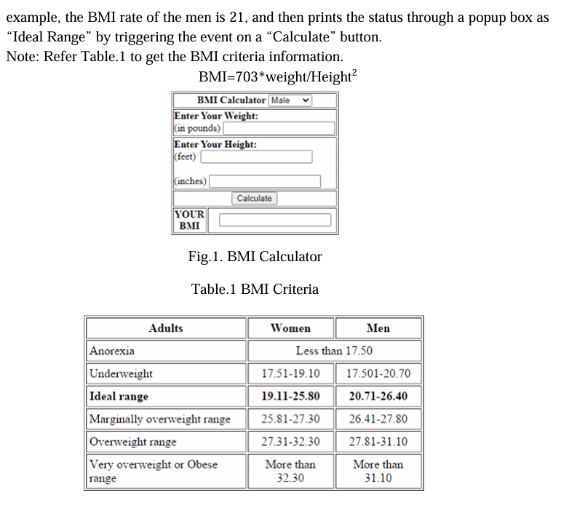

<!DOCTYPE html>

<html lang="en">

  <head>

    <meta charset="UTF-8" />

    <meta name="viewport" content="width=device-width, initial-scale=1.0" />

    <title>22BCE1351</title>

    <style>

      body {

        font-family: Arial, sans-serif;

        background-color: #f4f4f4;

        display: flex;

        flex-direction: column;

        justify-content: center;

        align-items: center;

        height: 100vh;

        margin: 0;

        padding: 20px;

      }

      .bmi-calculator {

        background-color: #fff;

        border-radius: 8px;

        box-shadow: 0 0 10px rgba(0, 0, 0, 0.1);

        margin-bottom: 20px;

        max-width: 400px;

        width: 100%;

        padding: 20px;

        box-sizing: border-box;

      }

      .bmi-calculator h2 {

        margin-bottom: 20px;

        text-align: center;

      }

      .bmi-calculator label {

        display: block;

        margin-bottom: 5px;

      }

      .bmi-calculator input[type="number"] {

        padding: 8px;

        margin-bottom: 10px;

        border: 1px solid #ccc;

        border-radius: 4px;

        width: calc(100%);

        box-sizing: border-box;

      }

      .bmi-calculator button {

        width: 100%;

        padding: 10px;

        background-color: #007bff;

        color: #fff;

        border: none;

        border-radius: 4px;

        cursor: pointer;

      }

      .bmi-calculator button:hover {

        background-color: #0056b3;

      }

      .bmi-calculator .result {

        margin-top: 20px;

        padding: 10px;

        border: 1px solid #ccc;

        border-radius: 4px;

        text-align: center;

        background-color: #e9f7ef;

      }

      .table-container {

        background-color: #fff;

        padding: 20px;

        border-radius: 8px;

        box-shadow: 0 0 10px rgba(0, 0, 0, 0.1);

        width: fit-content;

      }

      table {

        width: 100%;

        border-collapse: collapse;

      }

      th,

      td {

        border: 1px solid #ddd;

        padding: 12px;

        text-align: left;

      }

      th {

        background-color: #f2f2f2;

      }

      tr:nth-child(even) {

        background-color: #f9f9f9;

      }

      caption {

        font-size: 1.5em;

        margin-bottom: 10px;

        color: #333;

      }

    </style>

  </head>

  <body>

    <div class="bmi-calculator">

      <h2>BMI Calculator</h2>

      <label for="weight">Enter Your Weight (in pounds):</label>

      <input

        type="number"

        class="inputbox"

        id="weight"

        placeholder="Weight in pounds"

      />

      <label for="feet">Enter Your Height (feet):</label>

      <input type="number" id="feet" placeholder="Feet" />

      <label for="inches">Enter Your Height (inches):</label>

      <input type="number" id="inches" placeholder="Inches" />

      <button onclick="calculateBMI()">Calculate</button>

      <div class="result" id="result">Your BMI will be displayed here.</div>

    </div>

    <div class="table-container">

      <table>

        <caption>

          BMI Criteria

        </caption>

        <thead>

          <tr>

            <th>Adults</th>

            <th>Women</th>

            <th>Men</th>

          </tr>

        </thead>

        <tbody>

          <tr>

            <td>Anorexia</td>

            <td>Less than 17.50</td>

            <td>Less than 17.50</td>

          </tr>

          <tr>

            <td>Underweight</td>

            <td>17.51-19.10</td>

            <td>17.501-20.70</td>

          </tr>

          <tr>

            <td><strong>Ideal range</strong></td>

            <td><strong>19.11-25.80</strong></td>

            <td><strong>20.71-26.40</strong></td>

          </tr>

          <tr>

            <td>Marginally overweight range</td>

            <td>25.81-27.30</td>

            <td>26.41-27.80</td>

          </tr>

          <tr>

            <td>Overweight range</td>

            <td>27.31-32.30</td>

            <td>27.81-31.10</td>

          </tr>

          <tr>

            <td>Very overweight or Obese range</td>

            <td>More than 32.30</td>

            <td>More than 31.10</td>

          </tr>

        </tbody>

      </table>

    </div>

    <script>

      function calculateBMI() {

        const weight = parseFloat(document.getElementById("weight").value);

        const feet = parseFloat(document.getElementById("feet").value);

        const inches = parseFloat(document.getElementById("inches").value);

        if (isNaN(weight) || isNaN(feet) || isNaN(inches)) {

          document.getElementById("result").innerText =

            "Please enter valid numbers.";

          return;

        }

        const heightInInches = feet \* 12 + inches;

        const bmi = (weight / (heightInInches \* heightInInches)) \* 703;

        document.getElementById(

          "result"

        ).innerText = `Your BMI is: ${bmi.toFixed(2)}`;

      }

    </script>

  </body>

</html>

